**Lab Report # 08**



**Spring 2019**

**CSE 103L, Circuits & Systems-1**

Submitted by: **Shah Raza**

Registration No. : **18PWCSE1658**

Class Section: **B**

“On my honor, as student of University of Engineering and Technology, I have neither given nor received unauthorized assistance on this academic work.”

Student Signature: ______________

Submitted to:

**Engr. Muniba Ashfaq**

April 30, 2019

**Department of Computer Systems Engineering**

**University of Engineering and Technology, Peshawar**

**OBJECTIVES:**

1. To know the definition of resistance.
2. To know the unit of resistance and its definition
3. To know how to get the required voltage in a circuit
4. To know how to drop the voltage in a circuit
5. To know about series and parallel circuits

**SERIES CIRCUIT:**

**DEFINITION:**

**“**A series circuit is a closed circuit in which the current follows one path”

**EXPLANATION:**

In a series circuit, the current through each load is the same and the total voltage across the circuit is the sum of the voltages across each load, where the total resistance is equal to the sum of the individual resistances.

I=I1=I2=I3=In

V=V1+V2+V3+…. +Vn

RT=R1+R2+R3+…. Rn

A series circuit will not function if one part is broken; that is, the current will not flow through the rest of the circuit.

**PARALLEL CIRCUIT:**

**DEFINITION:**

**“**A parallel circuit is a closed circuit in which the current divides into two or more paths before recombining to complete the circuit”

**EXPLANATION:**

In a parallel circuit, the voltage through each load is the same and the total current across the circuit is the sum of the current across each load, where the total resistance is equal to the sum of reciprocal of the individual resistances, and total resistance is always less than smallest individual resistance.

V=V1=V2=V3=Vn

I=I1+I2+I3+…. +In

**COMPONENTS REQUIRED:**

* Power supply
* 33Ω
* 22k Ω
* 570 Ω
* 44.2 Ω
* Connecting Wires

**PROCEDURE:**

1. Provide 5V to breadboard.
2. For first branch, connect 33kΩ , 22k Ω and 570Ω resistors in series and then connect 44.2 Ω resistor in parallel with them.
3. Measure voltage at 44.2Ω resistor using DMM and that voltage will be approximately 2V

CIRCUIT DIAGRAM IN PSPICE:

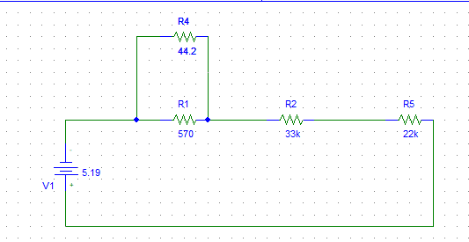 **CALCULATION AND DISCUSSION:**

|  |  |  |  |  |  |
| --- | --- | --- | --- | --- | --- |
| **V Theoretical** | | | | | |
| **Vs** | **R1** | **R2** | **R3** | **R4** | **V Total** |
| 5.19V | 570Ω | 22k Ω | 33kΩ | 44.2Ω | 5V |

**CONCLUSION:**

After attending this lab, it is understood that any typr of voltage can be obtained from any type of input voltage if proper set of resistors are used.